BACKEND OUTPUT:

STS TOOLS USED FOR BACKEND

MYSQL WORKBENCH FOR DATABASE

1. RUN OF EUREKA SERVER-STS TOOL

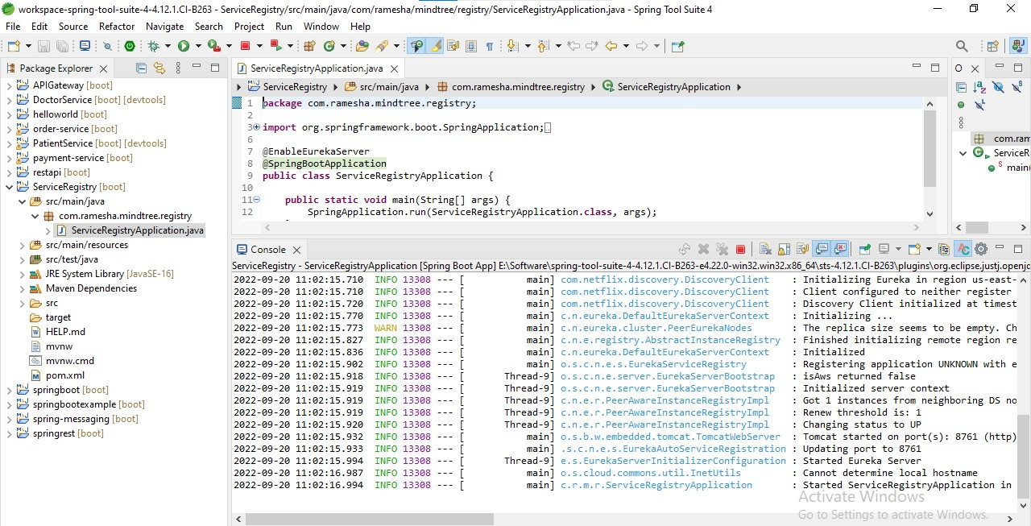

1. RUN OF APIGATEWAT SERVER-STS TOOL

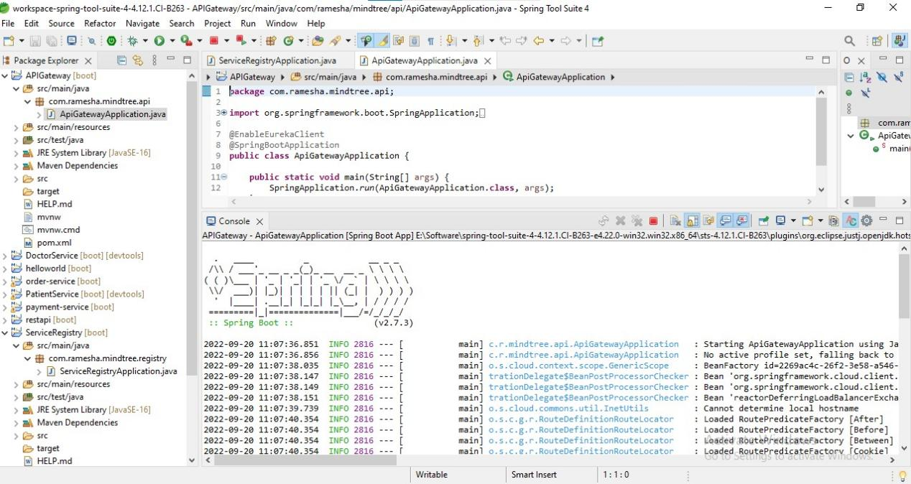

1. RUN OF DOCTOR SERVER-STS TOOL

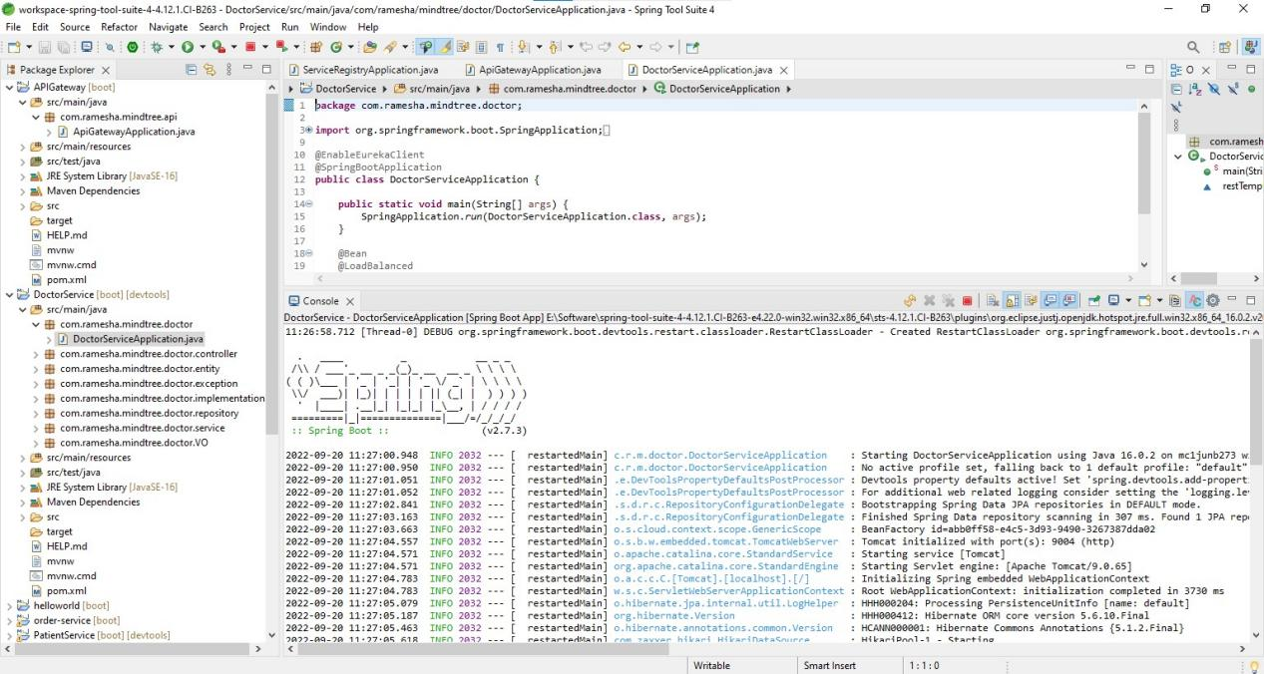

1. RUN OF PATIENT SERVER-STS TOOL

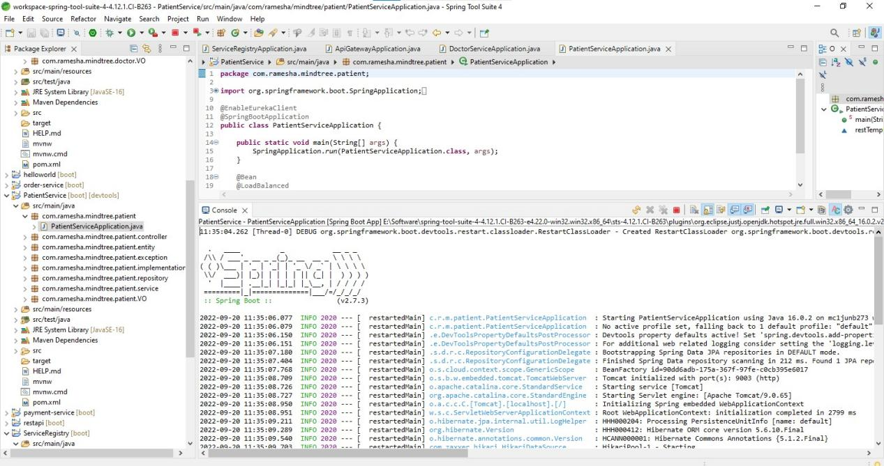

1. EUREKA SERVER ON BROWSER-8761 PORT

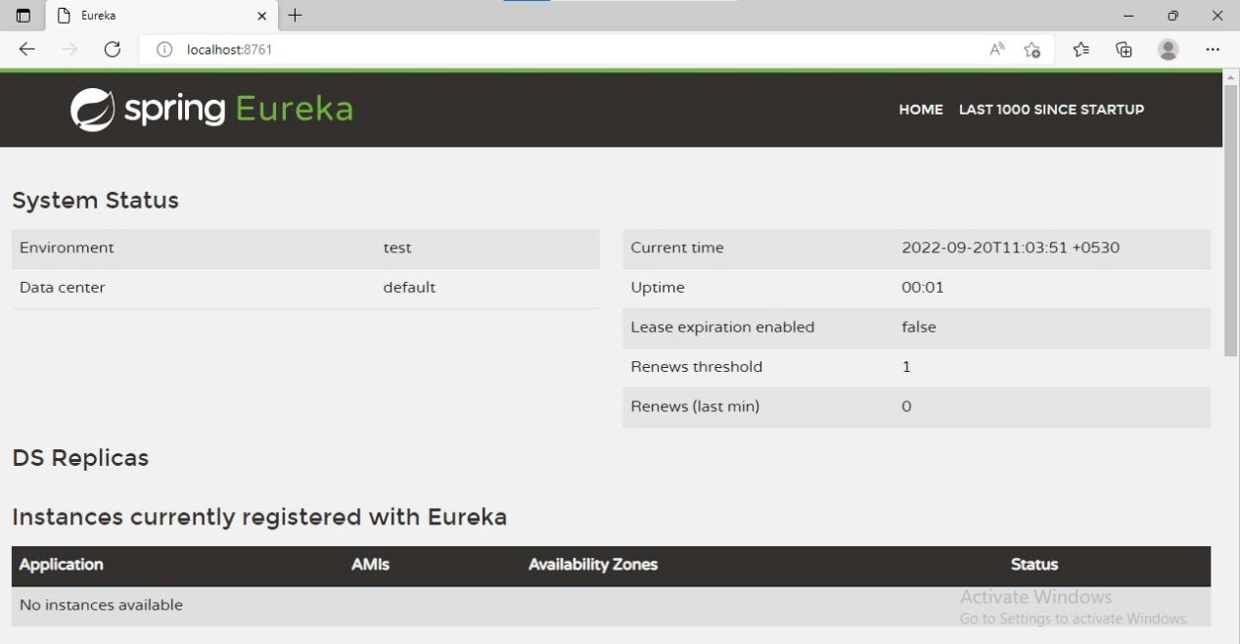

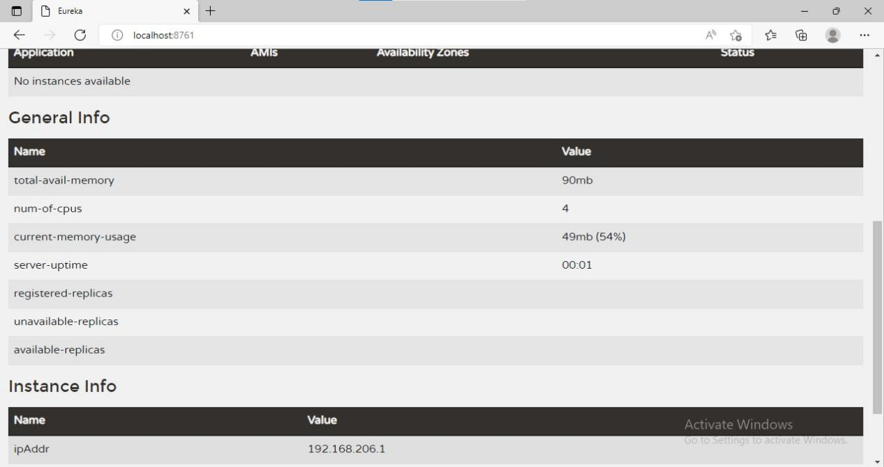

1. APIGATEWAY LOADED

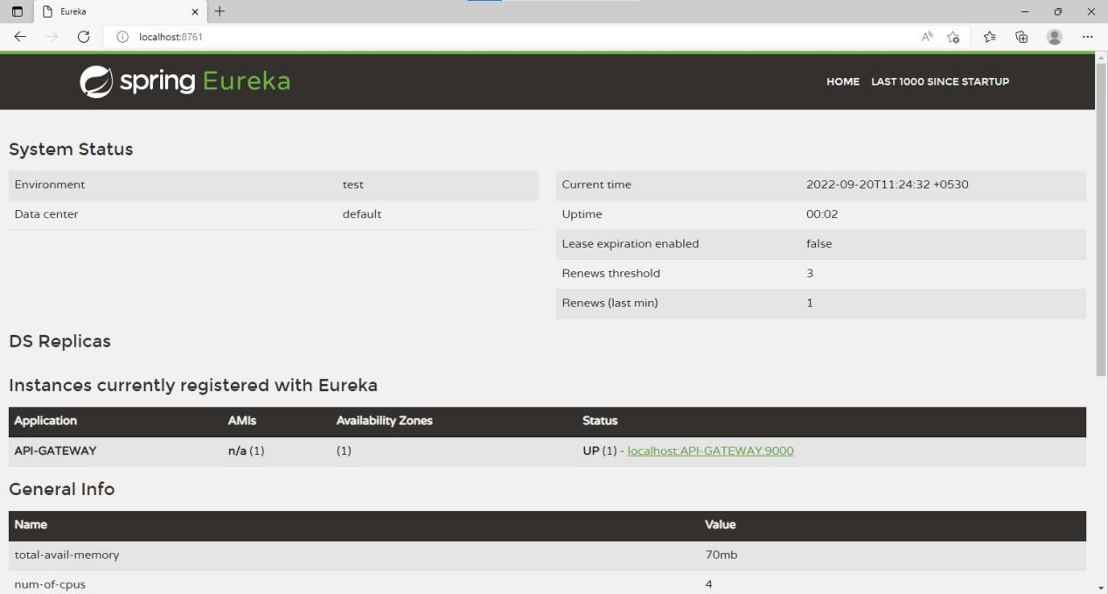

1. DOCTOR SERVICE LOADED TO SERVER

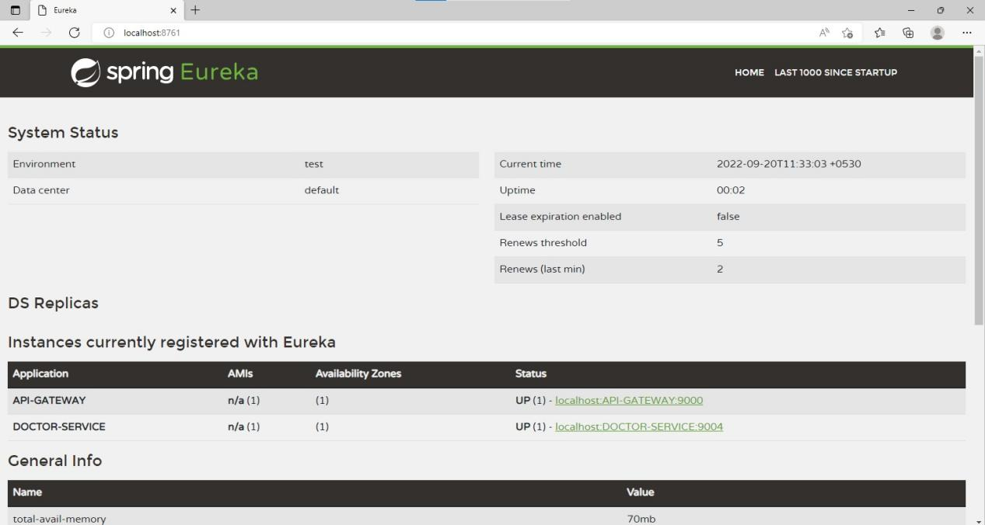

1. PATIENT SERVICE LOADED TO SERVER

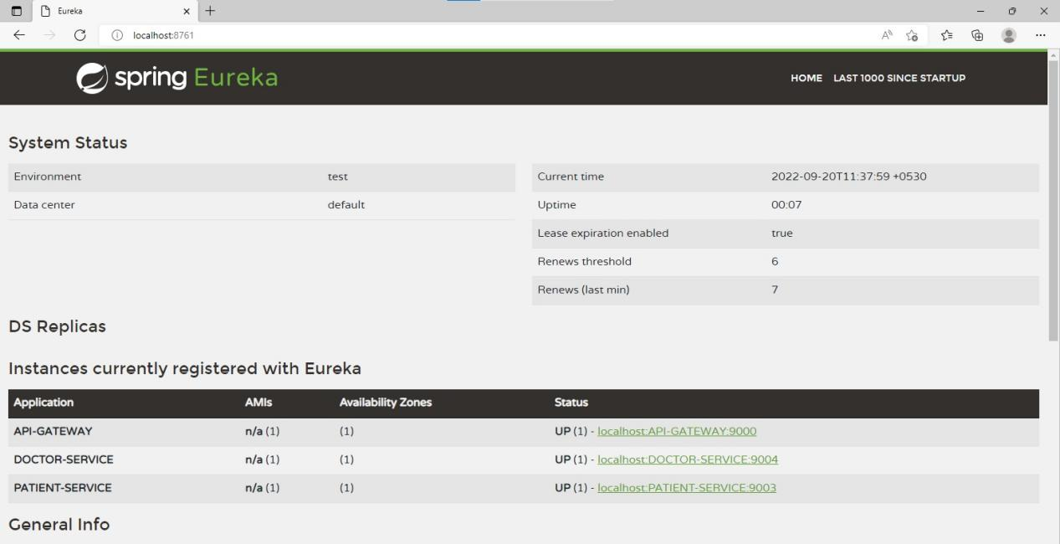

1. DATABASE CREATED-HOSPITAL MANAGEMENT DB NAME

WITH TABLE DOCTOR AND PATIENT.

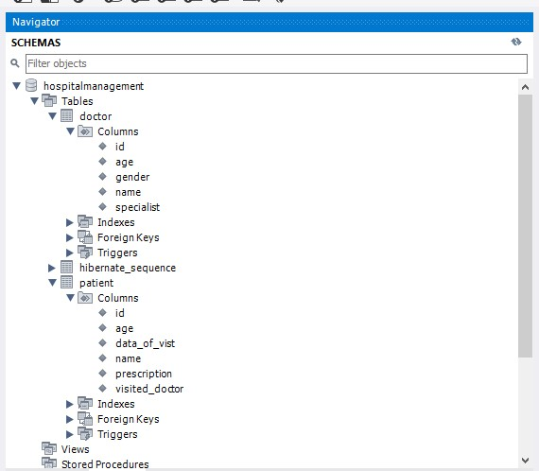

FRONTEND ANGULAR DESIGN

1. FRONTENDRUNNING LOCALHOST 4200

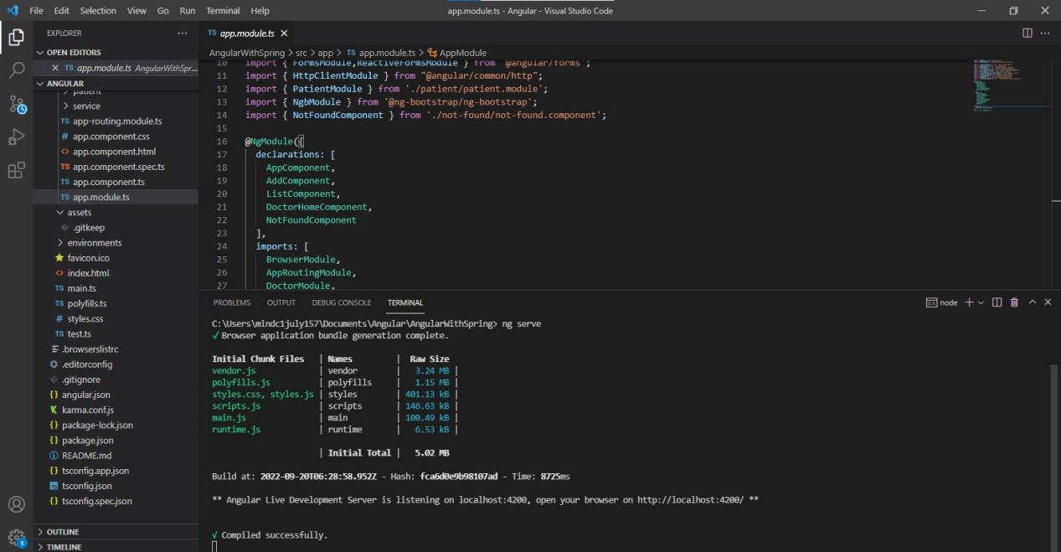

1. HOME PAGE

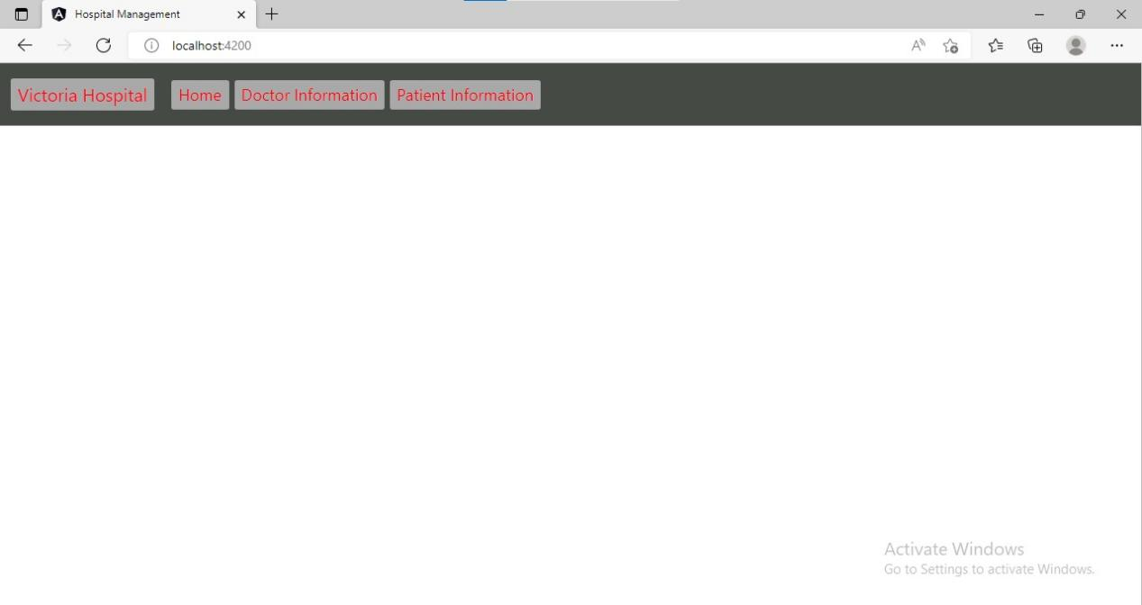

1. CREATE DOCTOR

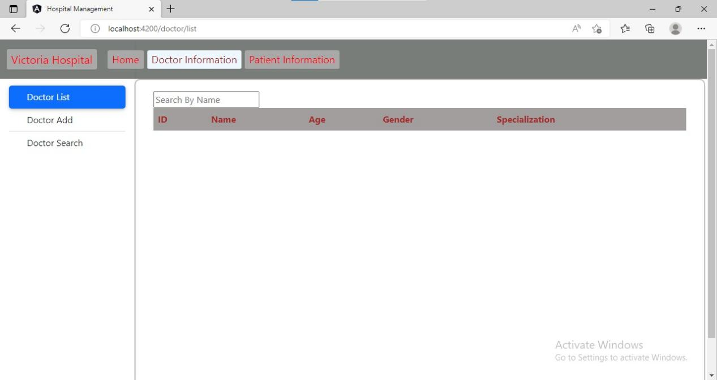

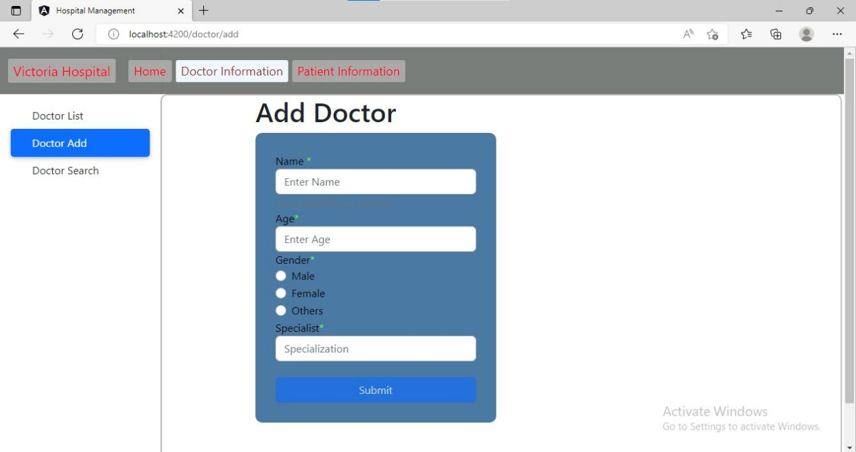

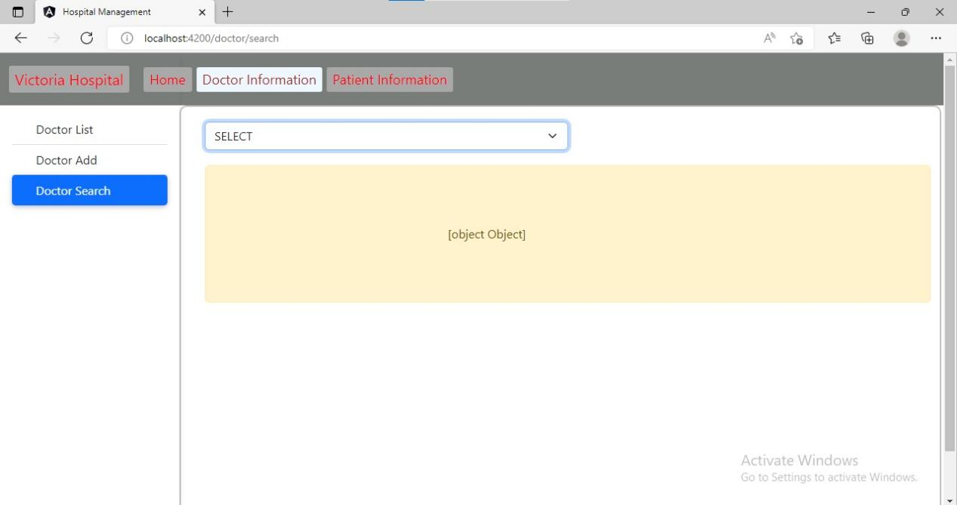

1. CREATE PATIENT

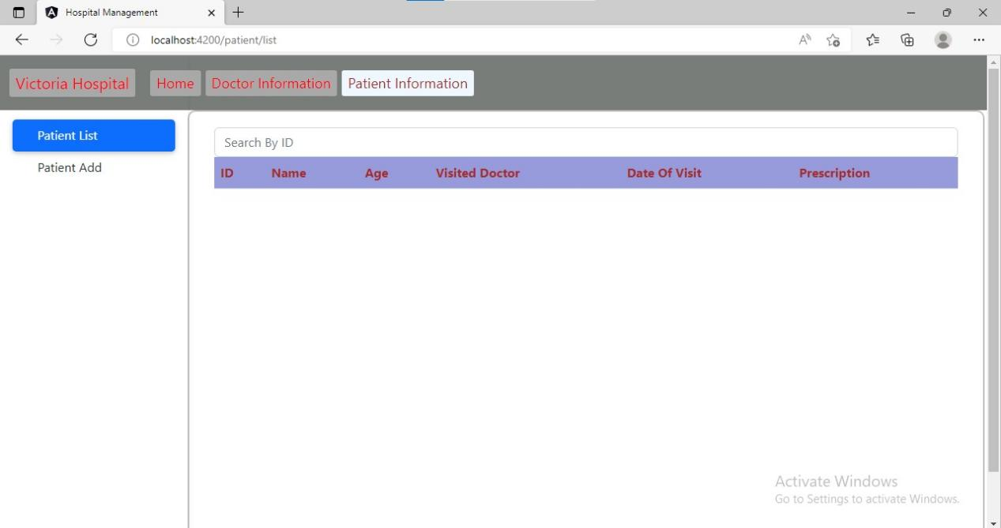

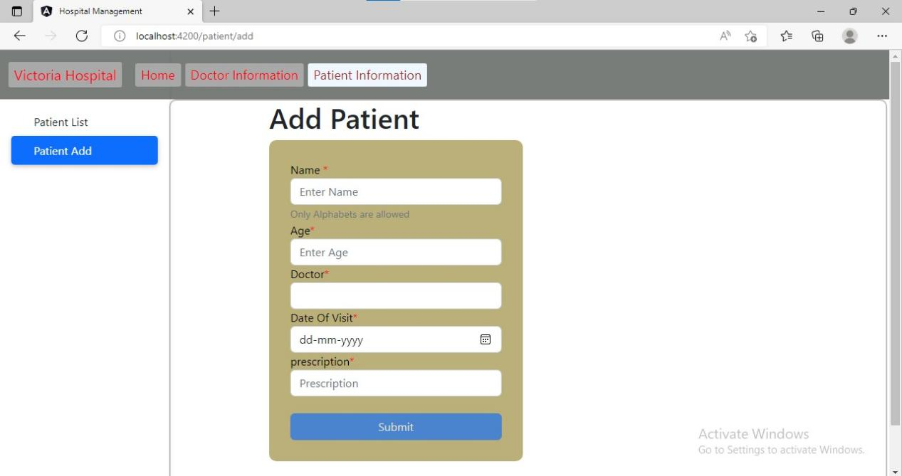

1. DOCTOR ADDING

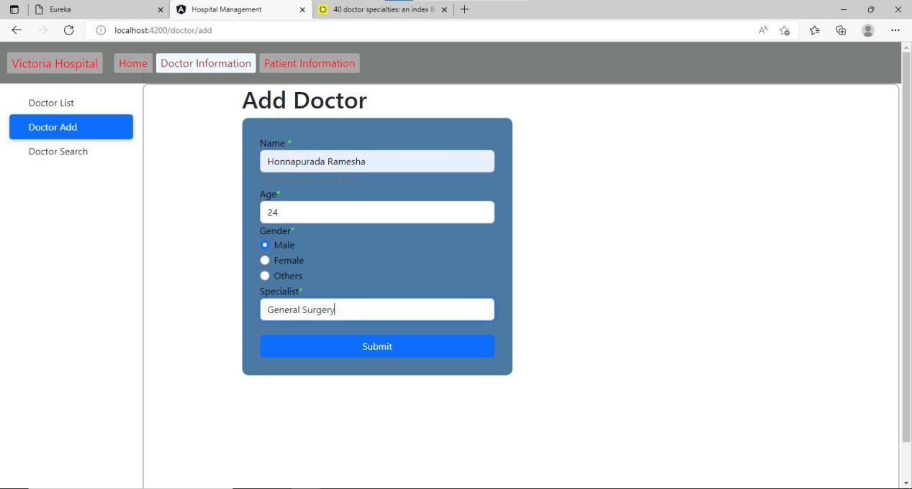

1. ALERT SUCCESSFUL ADDITION WITH DOCTOR

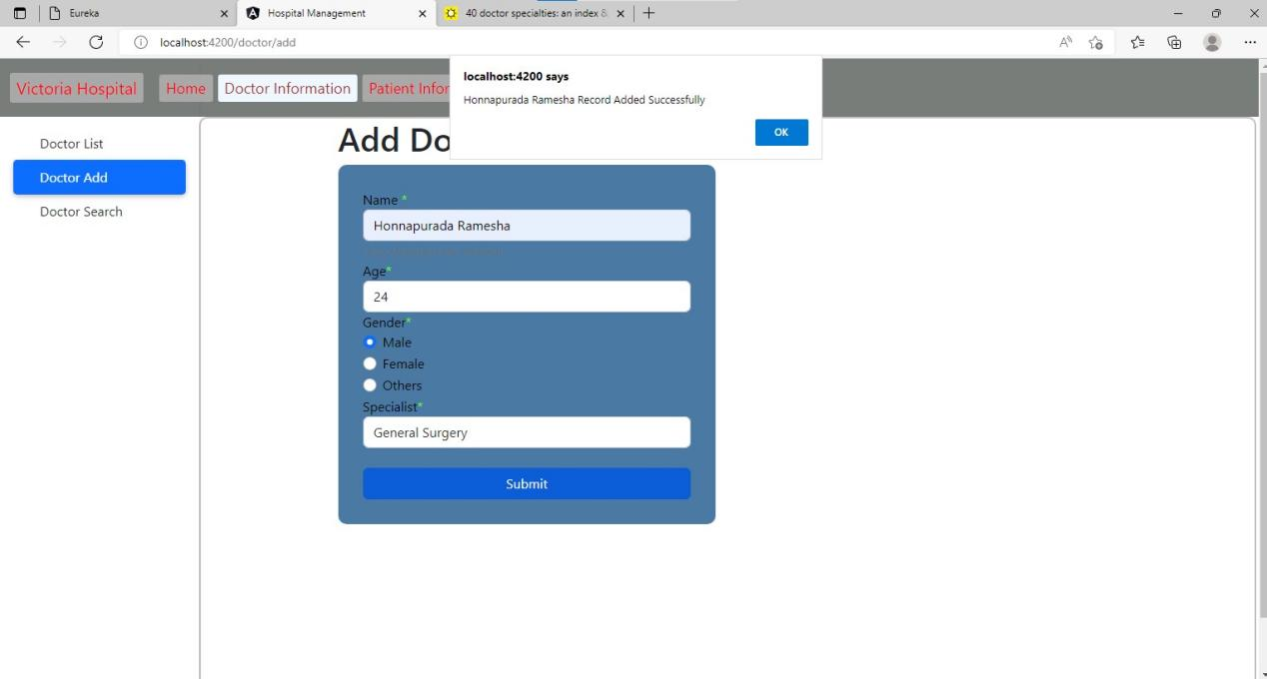

1. 16.DOCTOR ADDING DATA THAT GOES TO DATABASE

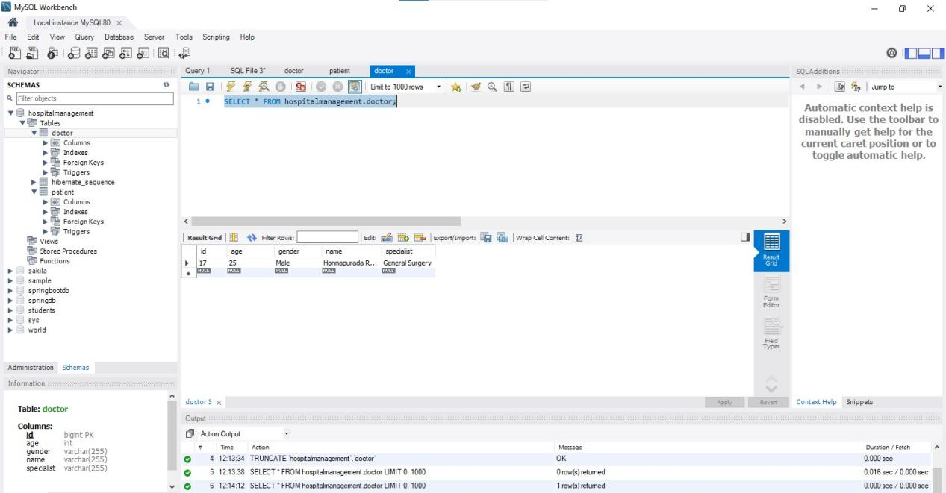

1. PATIENT ADDING

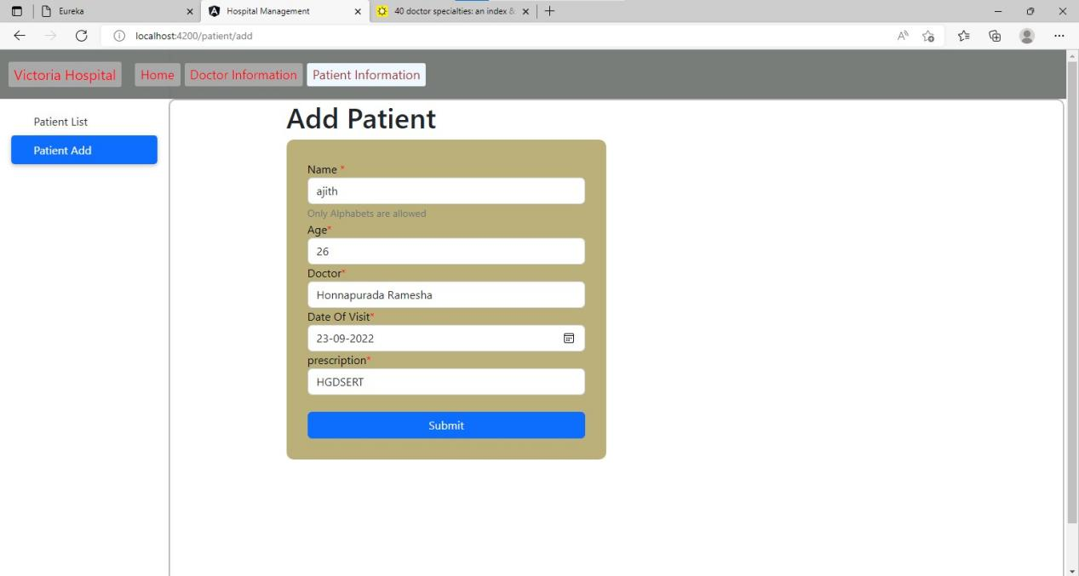

1. ALERT WITH SUCCESSFUL ADDITION PATIENT

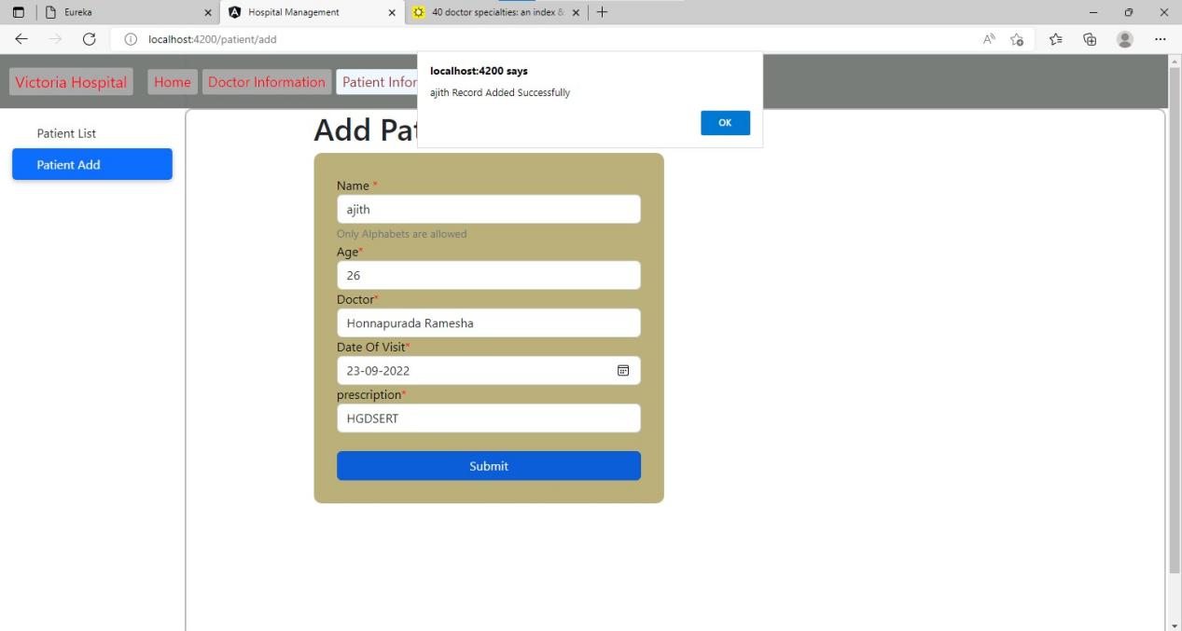

1. PATIENT ADDED TO DATABASE FROM FRONTEND

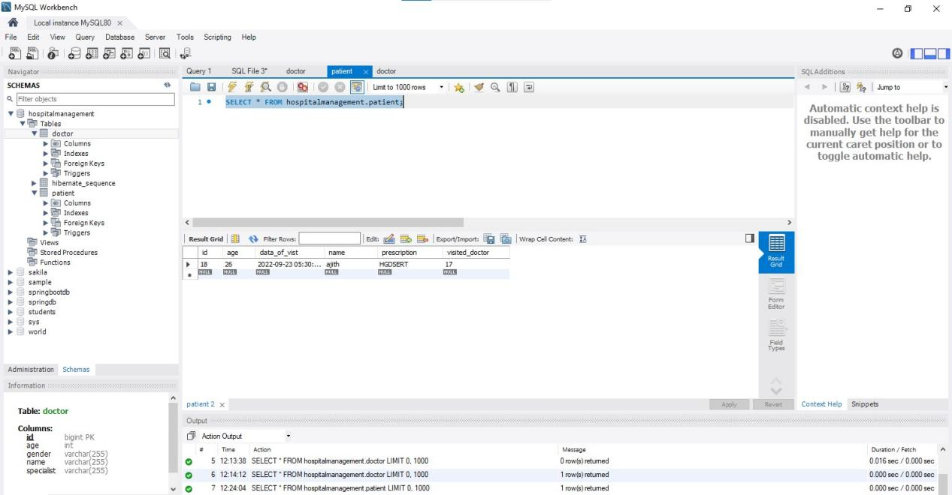

1. DOCTOR LIST

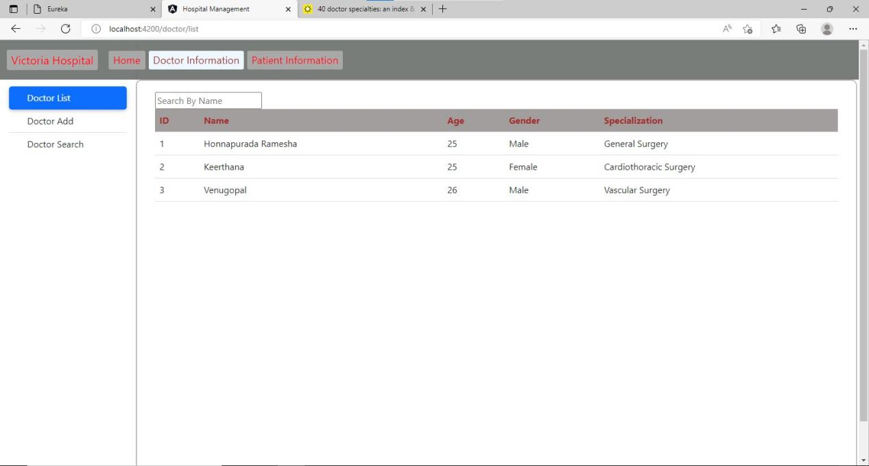

1. DOCTOR SEARCH

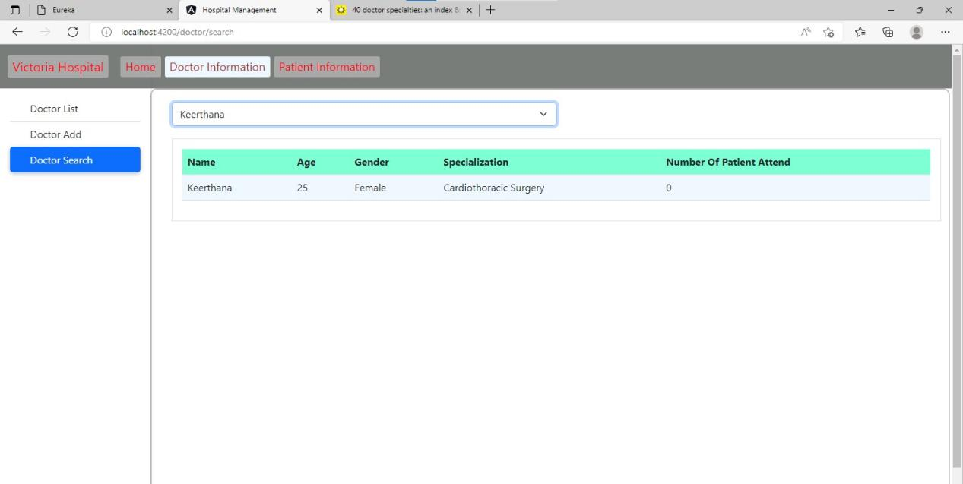

1. PATIENT LIST

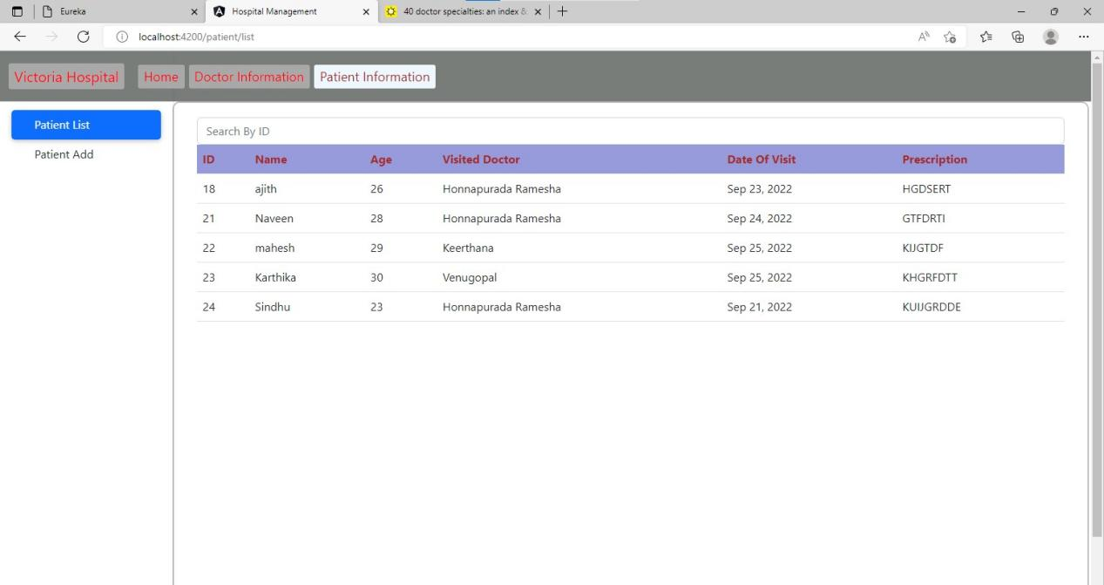

1. DOCTOR NUMBER OF PATIENT ATTEND LIST

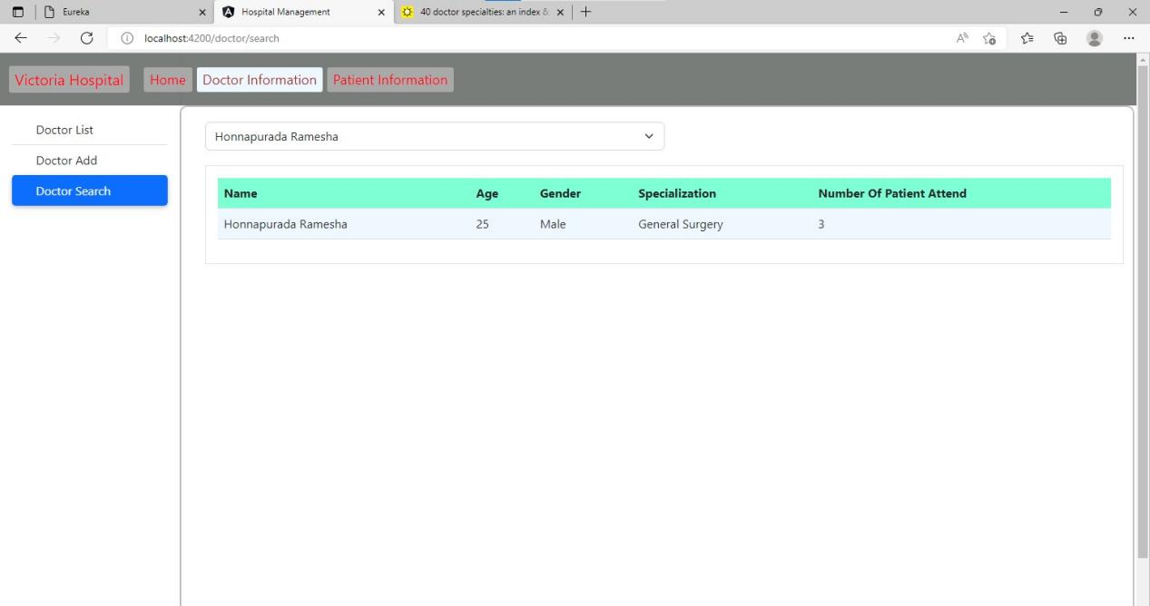

1. DOCTOR ADDED TO DATABASE FROM FRENTEND

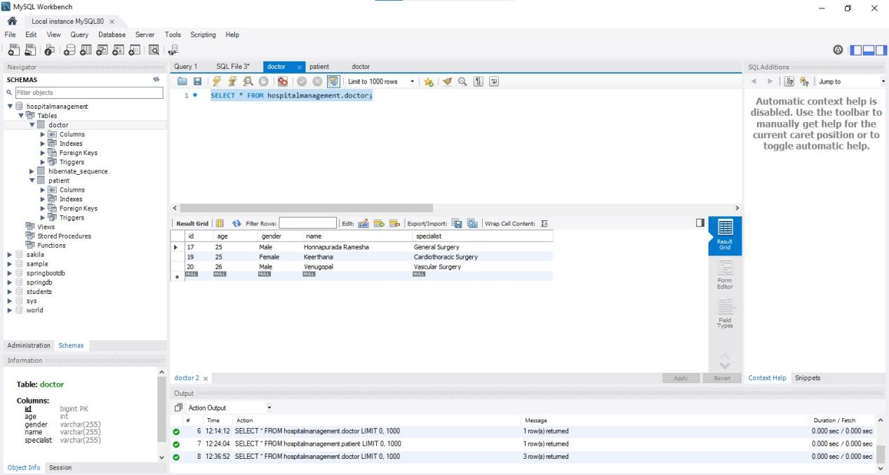

1. PATIENT ADDED TO DATABASE FROM FRENTEND

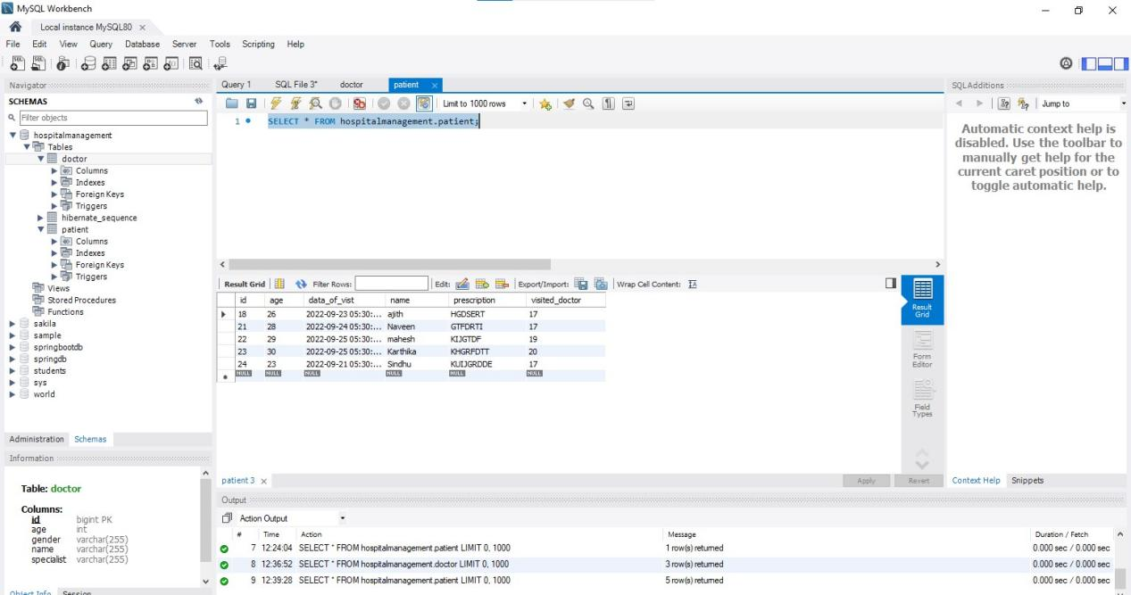

1. KARMA AND JASMINE RUNNING

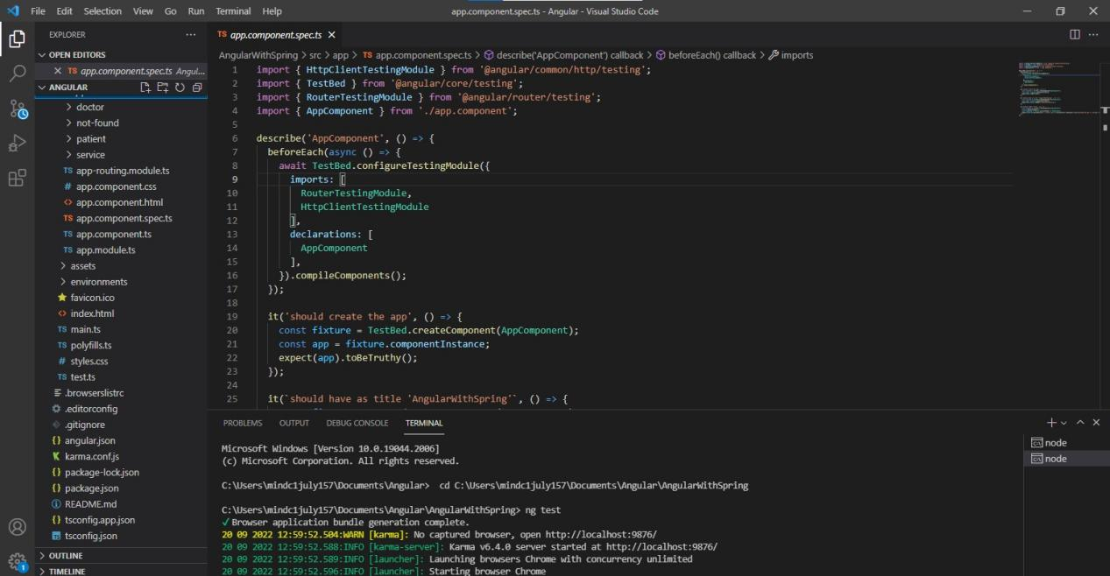

1. KARMA AND JASMINE LOADING

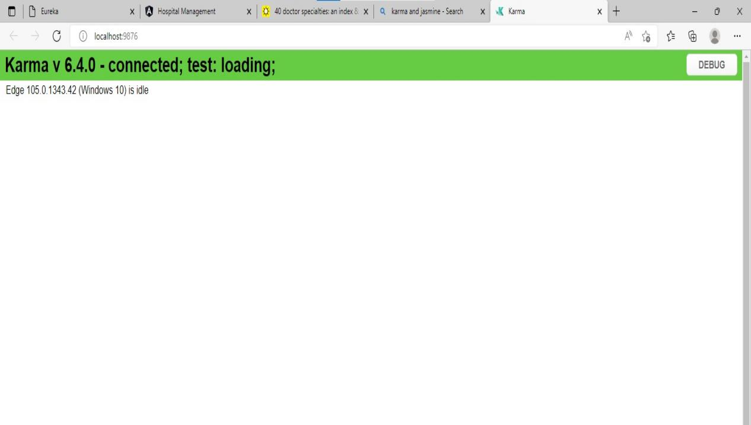

1. TEST JUNIT CONTROLLER LAYER

